|  |
| --- |
| South Africa Livelihood Zone Profile  59104 – Highveld border open access livestock (*ZABOL*) |
| Zone Description |

This livelihood zone lies on the Swaziland border of Mpumalanga Province, much of it on the highland ridge between the Nkomati and Mpuluzi Rivers (a small section around Fernie lies south of the Mpuluzi River and another section around Tjakastad is north of the Nkomati. It is a part of Chief Albert Luthuli Municipality in Gert Sibande District. The livelihood zone is also is situated on the border of the country, with the crossing into Swaziland located at Oshoek. Nearby there are large agroforestry plantations which also serve as employment for residents. Winters in the area are extremely cold. It is accessed by feeder roads that connect to the N17 highway to from Ermelo to Swaziland.

Figure 2: Livelihood zone location

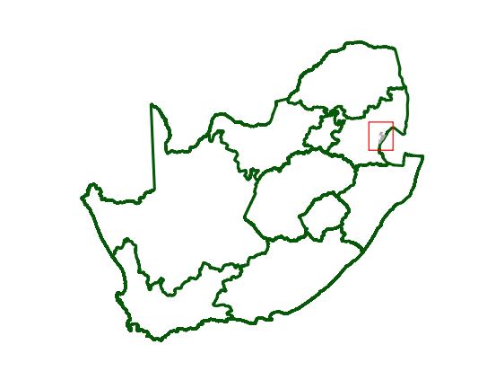

Figure 1: Map of the livelihood zone

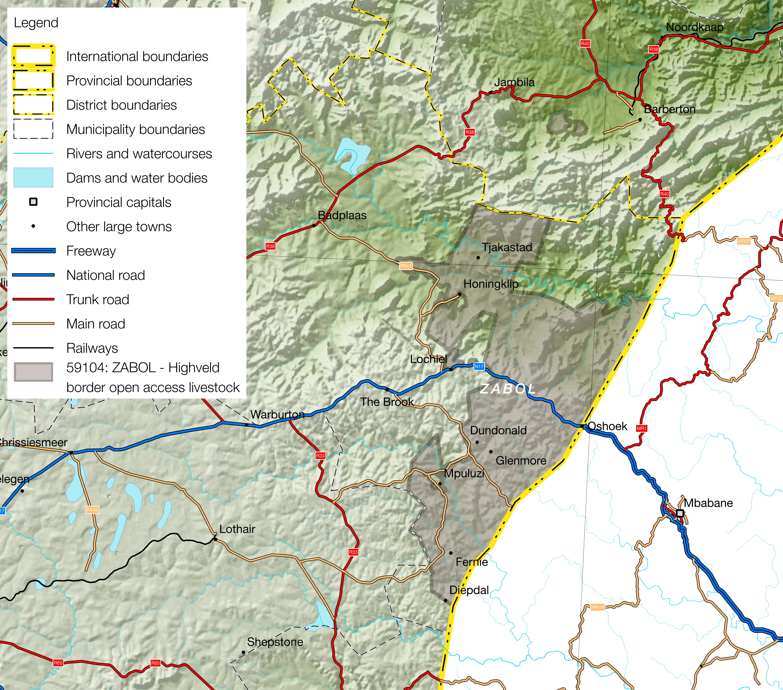

Projection: Albers Equal Area with Standard Parallels at 24.2 ªS and 32.8 ªS, Longitude of Centre at 25.1 ªE.

Sources of data: Open Street Map, Highways (<http://wiki.openstreetmap.org/wiki/Planet.osm>) for the road lines, Shuttle Radar Topography Mission (SRTM) 3 version 2.1 (<http://www2.jpl.nasa.gov/srtm/>) for the elevation and relief shading and Agricultural Geo-referenced Information System (AGIS) (<http://www.agis.agric.za/agisweb/agis.html>) for place names, boundaries and rivers.

The zone receives rainfall that ranges from 500mm to 700mm, well watered but mountainous, being characterised as having poor soils and good pastures that lend themselves better to cattle husbandry.

Many households in the zone were forcibly removed from Carolina and settled in the area under the Group Areas Act during Apartheid. A minority of people migrated over the border from Swaziland. There are also some former commercial farms lands that have been resettled under the Land Redistribution for Agriculture Development (LRAD) grants programme. The livelihood zone also benefits from programmes such as the (CWZ). Crops are grown in the valleys, while livestock are grazed on the hills. Wealthier households keep cattle and goats, making use of the extensive grazing in the surrounding veld. Crops grown include maize, groundnuts, potatoes, sweet potatoes, beans and vegetables. Households also depend on casual labour, remittances and grants, although formal sector jobs are scarce and some households lack the necessary papers such as identity documents required to obtain their grants.

Table I - 2016 Population breakdown of districts and municipalities covered by the livelihood zone, based on the 2011 Census and annual projections

|  |  |  |  |  |
| --- | --- | --- | --- | --- |
| **Province** | **District** | **Municipality** | **Pop. Est. in ZABOL** | **% of Admin Level** |
| Mpumalanga | Ehlanzeni | Umjindi | 2,825 | 4.11% |
| Gert Sibande | Albert Luthuli | 127,186 | 62.44% |
| **Provincial Total** | | | **130,011** | | | **2.98%** |

Source: Statistics South Africa, Census 2011 small area population data and district population projections

**Figure 1** is a map of the zone and **Figure 2** shows the location in the country. The zone is served by the N17 and the R541, as well as a sealed side roads through Dundonald, Mpuluzi and Fernie. Nhlazatje, Lochiel and Mpuluzi are the main town centres that are located in the zone.

The livelihood zone has been given an alphabetic code (or abbreviation) of ‘ZABOL’ and the numeric code of 59104. These codes distinguish the zone both nationally and internationally, as well as allowing zone name changes and updates if desired (the code should always remain the same).

The zone is almost entirely located in one municipality: Chief Albert Luthuli in Gert Sibande District and includes approximately 127,000 people in 2016 (this excludes people living in the more urban centres). There is also a tiny section of the zone around Emnjandini Trust town centre in Umnjindi Municipality, Ehlanzeni District, although the zone only accounts for about 2,800 people in 2016 in the surrounding rural areas and not the urban centre itself. The total population in the zone is 130,011 (in 2016, projected from the Census 2011) and this is 2.98% of the provincial total. **Table I** shows the breakdown for each municipality.

Figure 3: Gender and age breakdown of the zone population

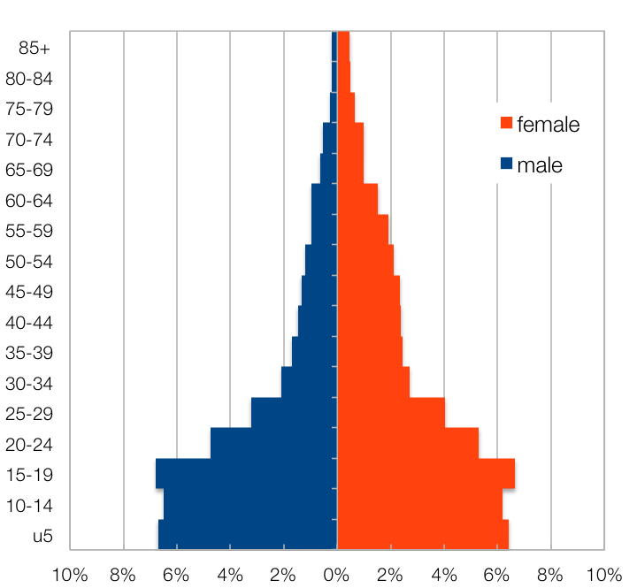

Source: Statistics South Africa, Census 2011 small areas and population database

The age and gender breakdown of the livelihood zone is given in **Figure 3**. There is a somewhat lower proportion of adult men than women in the livelihood zone as well as the high proportion of children (younger than 20). This unbalanced gender and dependency ratio is a continued consequence of apartheid, as most of the zone was a part of the former *bantustans*, supplying labour to urban, industrial, mining and commercial farming areas. The persistence of this pattern leads to shortages in the zone of human capital, which has impacts on productivity.

|  |
| --- |
| Seasonal Calendar |

Much of the rural life in the zone is still determined by agricultural seasons, although this has been ameliorated by employment, mining and social grants, which are year-round contributors to people’s livelihoods. Livelihoods information is organised temporally by *consumption year*, which begins with the start of the main dry harvest and runs through to just before the next year’s main dry harvest. In this zone, the main dry harvest begins in April, so the consumption year begins that month and runs up until the end of the following March. The livelihood strategies presented in this document also apply to a particular year, one that is neither very good nor bad, but is ‘typical’ or occurs frequently. This is called the *reference year* and the year chosen by participants was 2013-2014, or April 2013 to March 2014.

The main season for farming begins with land preparation in August and then proceeds throughout the spring, followed by ploughing and planting from October to December, depending on the timing of the rains. Weeding (a period of intense activity) takes place from December to February, with the green harvest starting in December and finishing in March. Dry harvesting takes place from April to July. Crops usually are sold, if that is possible, in July. Vegetables follow a slightly different pattern, with land preparation beginning in October and ending in December, overlapping with ploughing and planting from November to January, weeding from December to February and harvesting in April and May.

Milk production from livestock peaks during summer months, as do the animals’ heat cycles and births. Labour migration to commercial farms takes place in January and February, while hunting and fishing is most likely during the summer months. The hungriest time of the year is from August to October.

Figure 4: Seasonal calendar

|  |  |  |  |  |  |  |  |  |  |  |  |  |
| --- | --- | --- | --- | --- | --- | --- | --- | --- | --- | --- | --- | --- |
| **Activity** | Apr | May | Jun | Jul | Aug | Sep | Oct | Nov | Dec | Jan | Feb | Mar |
| Rainfall |  |  |  |  |  |  |  |  |  |  |  |  |
| Land preparation (maize) |  |  |  |  |  |  |  |  |  |  |  |  |
| Ploughing & planting (maize) |  |  |  |  |  |  |  |  |  |  |  |  |
| Weeding (maize) |  |  |  |  |  |  |  |  |  |  |  |  |
| Green consumption |  |  |  |  |  |  |  |  |  |  |  |  |
| Dry harvest & threshing |  |  |  |  |  |  |  |  |  |  |  |  |
| Crop sales |  |  |  |  |  |  |  |  |  |  |  |  |
| Land preparation(Vegetables) |  |  |  |  |  |  |  |  |  |  |  |  |
| Ploughing & planting (Vegetables) |  |  |  |  |  |  |  |  |  |  |  |  |
| Weeding (Vegetables) |  |  |  |  |  |  |  |  |  |  |  |  |
| Harvesting (vegetables) |  |  |  |  |  |  |  |  |  |  |  |  |
| Employment (domestic work, farm work, forestry) |  |  |  |  |  |  |  |  |  |  |  |  |
| Employment (EPWP, CWP) |  |  |  |  |  |  |  |  |  |  |  |  |
| Food Purchases |  |  |  |  |  |  |  |  |  |  |  |  |
| Food aid (Food parcels) |  |  |  |  |  |  |  |  |  |  |  |  |
| Mining |  |  |  |  |  |  |  |  |  |  |  |  |
| Milk production |  |  |  |  |  |  |  |  |  |  |  |  |
| Livestock sales |  |  |  |  |  |  |  |  |  |  |  |  |
| Heat and Births |  |  |  |  |  |  |  |  |  |  |  |  |
| Labour migration |  |  |  |  |  |  |  |  |  |  |  |  |
| Health (influenza, diarrhoea) |  |  |  |  |  |  |  |  |  |  |  |  |
| Hunting /Fishing |  |  |  |  |  |  |  |  |  |  |  |  |
| Hunger season |  |  |  |  |  |  |  |  |  |  |  |  |

|  |
| --- |
| Wealth Breakdown |

Wealth in this livelihood zone is determined primarily by three factors:

1. Formal employment—a product of education and good social connections—instead of social grants;
2. Ownership of a small business, such as a spaza shop or bakkie, taxi; and
3. 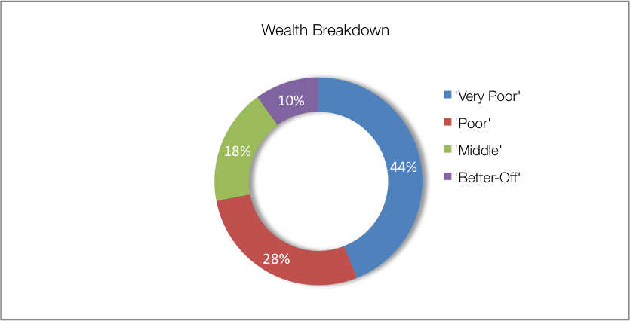Livestock, especially cattle.

Land holdings increase with wealth but not as exponentially as the factors listed above (0.25 ha for the poorest against 2 ha for the wealthiest). Wealthier households

Figure 5: Wealth breakdown in the highveld border open access livestock livelihood zone

|  |  |  |  |  |  |
| --- | --- | --- | --- | --- | --- |
| Category | Item | Wealth Group (typical value in brackets) | | | |
| 'Very poor' | 'Poor' | 'Middle' | 'Better off' |
| Hh Size |  | 7-12 (8) | 5-10 (8) | 3-8 (5) | 2-6 (4) |
| Land (Ha) | Owned | 0.09-½ (¼) | ¼-1 (½) | ½-2 (1) | 1-5 (2) |
| Cultivated | 0-½ (¼) | ¼-½ (¼) | ½-2 (1) | 1-3 (2) |
| Livestock (head) | Cattle | 0 | 0-4 (3) | 5-13 (10) | 10-25 (20) |
| Goats | 0 | 0-5 (3) | 5-9 (6) | 10-30 (20) |
| Income | Main source | Grants | Grants | Formal employ | Formal employ |
| Annual (R) | 27,300 | 48,100 | 117,900 | 309,500 |

Source: Survey output, October 2016

The wealthiest households, described as the ‘better-off’, are those with permanent work and a salary of around R14,000 per month. Households that have lower-paying or less permanent formal employment, which averages over the year to approximately R5,800 per month, are referred to as the ‘middle’. Those who depend primarily on grants are described as the ‘poor’ and ‘very poor’; collectively, they are about 72% of households. These ‘very poor’ and ‘poor’ supplement their grant income with casual labour, self-employment and, in very small quantities, crops and livestock.

‘Better-off’ households are able to develop slightly more land and produce crops for sale, using savings from their other income sources to afford inputs (including labour). Similarly, they derive a small cash benefit from their animals. Middle households also sell crops and livestock or livestock products.

In interviews key informants in the villages tended to provide larger household sizes, so field teams recorded values in excess of those reported during other surveys, especially the census. This is because the interviewees tended to view *family units* as households, combining 2 or 3 nuclear households into one unit for livelihoods analysis. This was considered the case because of familial sharing, where resources are often combined over 3 or more generations and across nuclear units headed by siblings.

|  |
| --- |
| Sources of Food |

Non-staple and staple purchases still make up the largest portion of people’s sources of food, with proportion of staple increasing with poverty. Food purchases contribute 70% to 83% of food energy needs; the ‘very poor’ obtaining the most this way. This compares with the purchases of the ‘better-off’ or ‘middle’ (73% and 70%, respectively). The contribution to food energy from *staple* food purchase *decreases* steadily from 66% for the ‘very poor’ to 30% for the ‘better-off’. Conversely, the contribution to food energy from non-staple foods increases with wealth from 16% to 42%. ‘Better-off’ households purchase less staple because that they prefer more luxurious and expensive non-staple foods.

Households from all wealth groups consume food from their own crop production, although the ‘very poor’ grow very little themselves (their contribution is only 7%). ‘Poor’, ‘middle’ and ‘better-off’ households consume 22%-37% from their own-produced crops, which increases with wealth. Own-produced non-staples are primarily cabbage, beans and groundnuts, while staples are maize and sometimes sweet potatoes.

Figure 6: Sources of food (expressed as percentage of minimum average food energy needs) for each wealth group

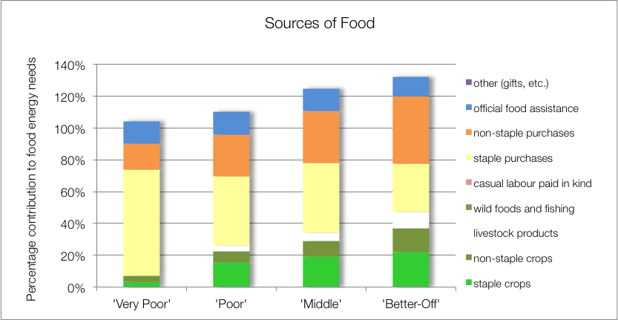

The ‘poor’, ‘middle’ and ‘better-off’ households obtain food from their livestock; this comes from occasional slaughter for meat and cow’s milk. Dairy production in this zone is below potential for the herd sizes and livestock ownership. With ‘better-off’ households especially, only a fraction of lactating cows (about one out of every five to ten) are actually milked for consumption.

All households’ children (including those from wealthier homes) receive additional food from school lunches, which is included as ‘official food assistance’.

|  |
| --- |
| Sources of Cash Income |

Cash incomes vary considerably across wealth groups, with the ‘better-off’ earning R309,500 per annum, more than eleven times as much as the ‘very poor'’ who earn only R27,300 per annum. **Figure 7** shows this distribution—it must be noted that each bar in the graphs is not a quartiles, the bars represent wealth groups and wealth groups are *not* distributed evenly (see **Wealth Breakdown**, above).

The largest sources of cash for households in the zone are: formal employment (for the ‘better-off’ and ‘middle’), small business (for the ‘better-off’), crop sales (for the ‘better-off’ only) and cash grants (for the ‘poor’ and ‘very poor’). This is in keeping with most surveys that ask for the single main livelihood source.

However, the point of this enquiry was to gain understanding of how *all* livelihood sources come together to make up an income. This is essential because it enables practitioners to link a hazard (such as a price change) to outcomes and it enables other users to see potential areas of intervention. By dividing the value of each source by the total income, we obtain these proportions and this is presented in the graph in **Figure 8**.

Figure 7: Sources of annual cash income by wealth group

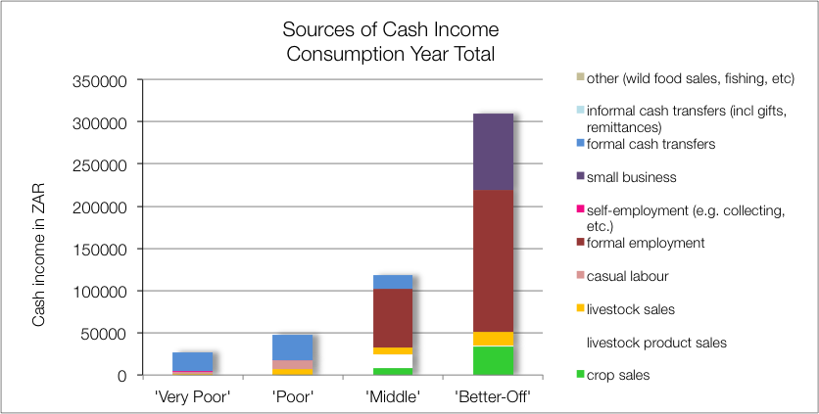

Grants make up 84% and 63% of the total cash income for the year for ‘very poor’ and ‘poor’ households, respectively. The remainder comes from casual labour (mostly domestic work, agricultural piece work and construction jobs), livestock sales, self-employment (collecting natural products for sale, weaving, making bricks, etc.), and a very small amount from crop sales (for the ‘poor’ only).

The ‘middle’ and 'better-off' gain their wealth from a formal wage or salary for the better part of their income. In the case of ‘middle’ households this may be from a member that works seasonally on the commercial farms but earnings typically range from amount to around R40,000 to R100,000 per year (R70,000 is typical, which is R 5,800 per month *average*). With 'better off' households, who often have permanent work, earnings are around R100,000 to R300,000 per year (median R168,000 per year or R14,000 per month).

Figure 8: Sources of annual cash income as a percentage of total, by wealth group

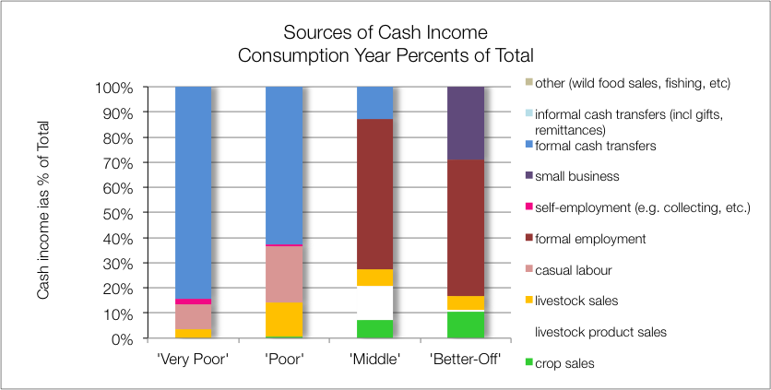

Households with established businesses also tend to be ‘better-off’, as these businesses require capital and bring in around R50,000 to R200,000 per year (median R90,000). Crops and livestock sales do bring in some income, although their earnings are far short of their income expectations. When ‘middle’ and ‘better-off’ households benefit from social grants it is usually for demographic reasons such as old age and fostering grants, which are not means-tested and the probability of a household containing a pensioner is about one in two—see the population pyramid under **Zone Description**).

|  |
| --- |
| Expenditure |

Absolute Expenditures are shown in  **Figure 9** and this varies across wealth groups in line with incomes.

Figure 9: Annual cash expenditure, by wealth group

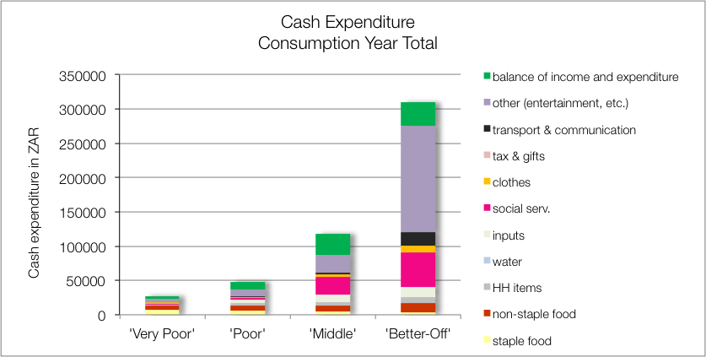

More interesting to the analyst are the relative expenses (as a proportion of total) and this is shown in  **Figure 10**. Here it can be clearly seen how the proportion of household income spent on foodstuffs declines as wealth increases: from 50% for the ‘very poor, to 28% for the ‘poor’, to 11% for the ‘middle’ and 6% for the ‘better-off’. This demonstrates dramatically how the ‘very poor’ and possibly the ‘poor’ can be vulnerable to food price shocks.

Figure 10: Annual cash expenditure as a percentage of total income, by wealth group

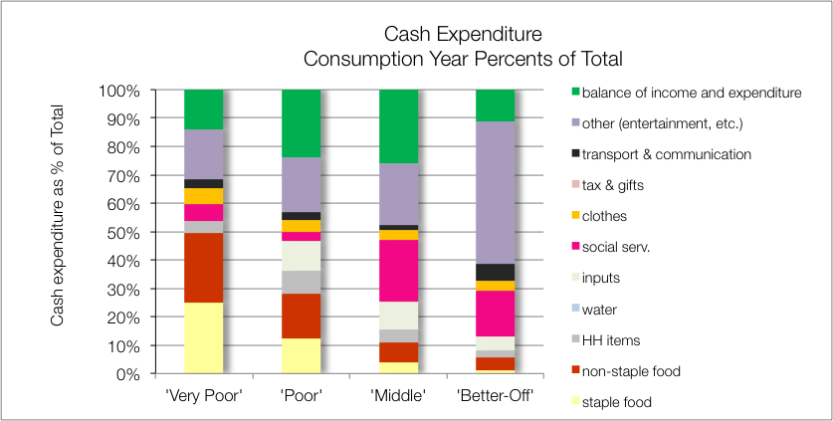

The proportion of income spent on social services such as education and health is higher for the ‘middle’ and ‘better-off’. Although the absolute amounts spent on inputs increases with increasing income, the proportions spent on this item are actually higher for the ‘poor’ and ‘middle’. Transport costs increase slightly with wealth, reflecting the added costs of owning a vehicle that the ‘better-off’ are likely to have.

Lastly, the proportion of income spent on entertainment and pleasure increases dramatically with wealth, underlining the fact that poverty is not necessarily a consequence of irresponsible behaviour.

|  |
| --- |
| Hazards, Vulnerabilities and Response Strategies |

Market-related shocks pose the biggest threat to the food security and living standards for the poorest households, since such a great proportion of the food is from the market and it consumes such a large proportion of their income. These ‘market shocks’ can be any or a combination of: escalating food prices, eroded grants (for example, when they are not adjusted to match consumer inflation) or work opportunity losses.

The *direct* impact of drought on food access for the ‘very poor’ and ‘poor’ is not significant—due to their lack of dependence on farming—but the *indirect* impact can be large through lost labour opportunities and potential food price hikes. For the poorest households, these latter two indicators should be monitored more closely than crop losses. The water scarcities caused by drought may also degrade living standards and will divert time and energy from other productive livelihood options.

Flooding may affect only the households living very low in the valleys but since this is a highland zone, very few households are at risk. More common risks include strong windy gusts with summer storms, hail, and lightning strikes. Located on the border, there are also risks from crime, with cattle rustling being a particular problem.

Additional response strategies households may engage in under stress are: switching expenditure, seeking more casual work (usually outside of the village) or selling off assets or belongings.

|  |
| --- |
| Food Insecurity Access Scale |

The majority (54 per cent) of the households in this Livelihood Zone were mildly food insecure. This was followed by 38 per cent of the households who were found to be moderately food insecure. Only four per cent of the households were found to be in a severe state of food insecurity. Another four per cent of the households were food secure in this livelihood zone.

Figure 11: Household food security access scale for the zone

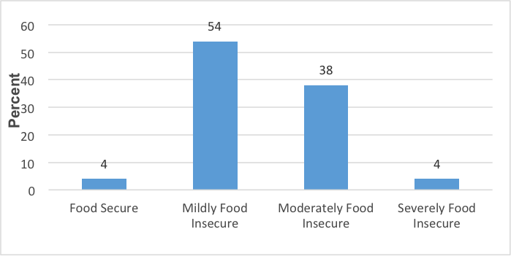

|  |
| --- |
| Household Hunger Scale |

The majority of the households (63 percent) experience no to little hunger and 11 per cent of households had severe hunger in this livelihood zone. About 26 per cent of the households reported a moderate hunger situation – see  **Figure 12**.

Figure 12: Household hunger scale in the zone

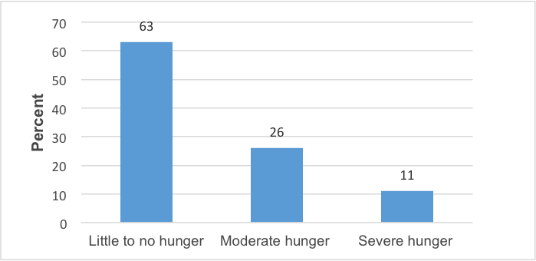

Figure 13: Food Consumption Scale in the zone

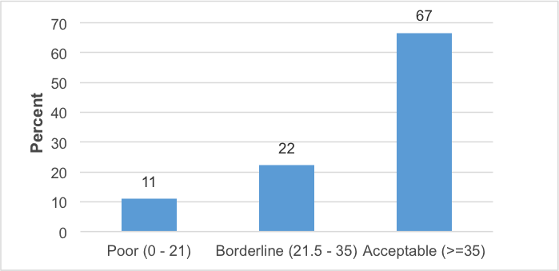

The majority of households—67 per cent—were found to be consuming acceptable diets. 22 Per cent of households were borderline and 11 per cent of the households consumed poor diets.

|  |
| --- |
| Nutrition and Anthropometry |

The under-five children of all age groups in this livelihood zone were s acutely malnourished. About 20 per cent of the children in the age grouping of 42-53 and 18-29 months old were moderately malnourished, respectively (**Figure 14**). In the rest of the age groups, no child was moderately or severely malnourished.

Figure 14: Prevalence of severe and moderate acute malnutrition in the zone

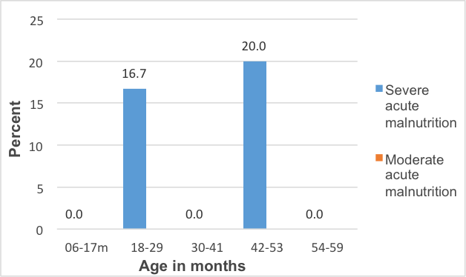

With regard to stunting, no surveyed under-five child was found to be severely or moderately stunted.

There was similarly no surveyed under-five child in this livelihood zone that was found to be severely or moderately underweight.

|  |
| --- |
| Conclusions and Recommendations |

Food and cash incomes from livestock products are low for the numbers of animals present. To increase production, herds would need more and better management, an investment that would need to be justified through better returns. These returns could be increased by, for example, support to dairy marketing and greater provision of services and infrastructure to encourage production. Crop farming yields could also be improved through greater service provision and market support, though crops are constrained by environmental factors. This increased productivity will unlikely benefit all but a few households directly, but will create additional new possibilities through increased work opportunities. For many 'poor' and 'very poor' households, grants will remain the main source of income for some time to come.

Figure 15: Detailed map of the livelihood zone showing the sampled sites, other livelihood zones, administrative areas down to enumeration small areas, and infrastructure

